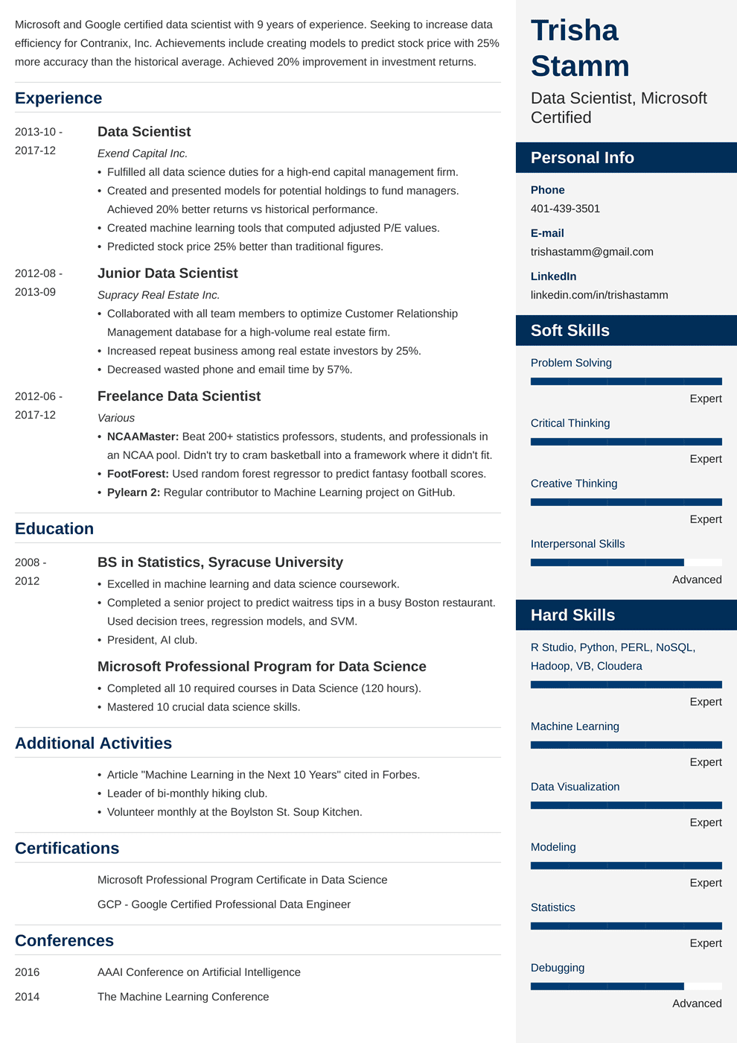
Microsoft and Google certified data scientist with 9 years of experience. Seeking to increase data efficiency for Contranix, Inc. Achievements include creating models to predict stock price with 25% more accuracy than the historical average. Achieved 20% improvement in investment returns.
Experience
2013-10-
2017-12
2012-08-
2013-09
2012-06-
Data Scientist
Exend Capital Inc.
• Fulfilled all data science duties for a high-end capital management firm.
• Created and presented models for potential holdings to fund managers. Achieved 20% better returns vs historical performance.
• Created machine learning tools that computed adjusted P/E values. • Predicted stock price 25% better than traditional figures.
Junior Data Scientist
Supracy Real Estate Inc.
• Collaborated with all team members to optimize Customer Relationship Management database for a high-volume real estate firm.
• Increased repeat business among real estate investors by 25%.
• Decreased wasted phone and email time by 57%.
Freelance Data Scientist
Trisha Stamm
Data Scientist, Microsoft Certified
Personal Info
Phone 401-439-3501
E-mail
trishastamm@gmail.com
LinkedIn
linkedin.com/in/trishastamm
Soft Skills
Problem Solving
Expert
2017-12
Critical Thinking
• NCAAMaster: Beat 200+ statistics professors, students, and professionals in an NCAA pool. Didn't try to cram basketball into a framework where it didn't fit.
Expert
• FootForest: Used random forest regressor to predict fantasy football scores. • Pylearn 2: Regular contributor to Machine Learning project on GitHub.
Creative Thinking
Various
Education
2008 - 2012
BS in Statistics, Syracuse University
• Excelled in machine learning and data science coursework.
• Completed a senior project to predict waitress tips in a busy Boston restaurant. Used decision trees, regression models, and SVM.
• President, Al club.
Microsoft Professional Program for Data Science
• Completed all 10 required courses in Data Science (120 hours). • Mastered 10 crucial data science skills.
Additional Activities
Expert
Interpersonal Skills
Hard Skills
Advanced
R Studio, Python, PERL, NoSQL, Hadoop, VB, Cloudera
Expert
Machine Learning
Expert
• Article "Machine Learning in the Next 10 Years" cited in Forbes.
Data Visualization
• Leader of bi-monthly hiking club.
• Volunteer monthly at the Boylston St. Soup Kitchen.
Certifications
Expert
Modeling
Microsoft Professional Program Certificate in Data Science GCP - Google Certified Professional Data Engineer
Expert
Statistics
Expert
Debugging
Conferences
2016
AAAI Conference on Artificial Intelligence
2014
The Machine Learning Conference
Advanced

